# Our Farmers & Food

* [Home](https://newroots.org/)
* Our Farmers & Food

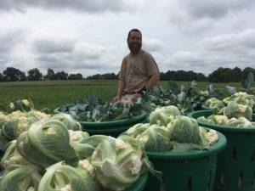

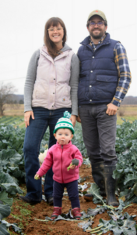

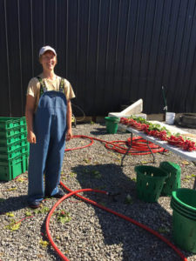

#### [**Rootbound Farm**](http://rootboundfarm.com/index.html)**, Oldham County, KY**

Rootbound Farm is owned by Bree Pearsall and Ben Abel (pictured left), with babies Sage and Hazel Grace. They are tenant farmers, utilizing 150 acres for sheep production and ten acres for certified organic vegetable production. They are entering their eight year of growing produce and they provide 50 percent of the produce purchased by New Roots’ Fresh Stop Markets. 35 percent of their income from vegetable production comes from the Fresh Stop Markets. Although neither grew up on a farm, both caught the “bug” at different phases of their lives: Ben as a young man whose parents were avid gardeners, Bree when she was offered a summer job picking tomatoes between college semesters.

*”Fresh Stop Markets allow us to build food justice into our business plan.”​*

Rootbound Farm also raises vegetables for Community Supported Agriculture (CSA), farmers’ markets, restaurants, and small groceries. They also raise grass-fed lamb and currently have about 75 sheep living on their farm. They farm because they love being able to run a family business that allows them to spend time outside and working with the land and the animals together as a family. They enjoy growing nutritious and delicious food for people that makes them feel good and brings them joy.

#### [**Ashbourne Farm**](http://ashbournefarms.com/)**, LaGrange, KY**

Ashbourne Farm is owned by Austin Musselman and his wife Janie. They are primarily a beef farm, but have a strong vegetable production utilizing organic practices.

Alaina Toebbe is the Vegetable Garden Manager at Ashbourne Farms, which has operated since 1937, when it was founded by W. L. Lyons Brown and his wife, Sara (Sally) Shallenberger Brown.

Today, the farm operates as a grass-fed beef, pastured pork, free-range chicken, non-GMO row crop, wildlife habitat, horse, honey and vegetable farm. They raise 3 acres of organically grown vegetables (not certified yet).

There are eight young people working on the vegetable garden crew this summer, and all are working hard and having fun growing vegetables for their CSA (Community Supported Agriculture), Farmers’ Market and Fresh Stop Markets.

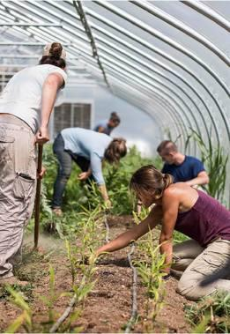

#### [**Valley Spirit Farm**](https://www.valleyspiritfarm.com/)**, Henry County, KY**

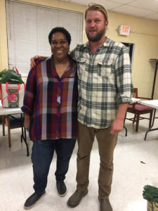

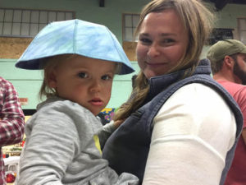

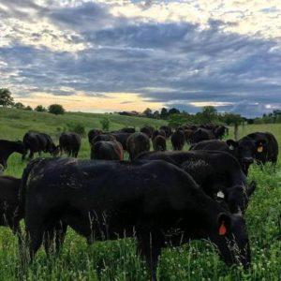

Valley Spirit Farm began in 2015 when the Monroe and Fiechter families embarked on a shared farming journey. Living and working together on 118 acres in Henry County, Kentucky, they strive to grow exceptional produce, mushrooms and pastured meats. Their farm currently hosts a 17 black angus cow-calf herd, and they custom graze black angus cattle for other local producers like Ashbourne Farms. They manage their cattle based on rotational grazing principles and work hard to not only provide high quality forage, but to build precious organic matter within the pastures through frequent moves of the herd. This keeps the grasses in a vegetative state and encourages root development, thus improving soil quality and quantity. Valley Spirit Farm also raises pastured pork and of course seasonal produce and mushrooms for the Fresh Stop Markets.

When asked why he is involved with the Fresh Stop Markets, farmer Joseph Monroe (pictured here next to New Roots Uber Farmer Liaison Ms. Mary Montgomery said,

*“Everyone I have met who is involved in the Fresh Stop Markets have been so inclusive and inviting, generous with their time and courageous, yet also humble in their role as part of the local food economy as organizers, leaders and eaters.”*

#### [**Barr Farms**](http://www.barrfarmsky.com/)**, Rhodelia, KY**

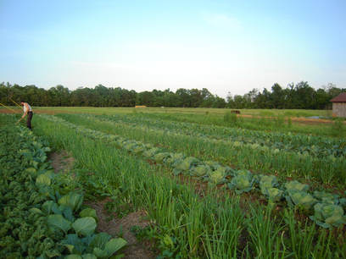

Adam and Rae Strobel Barr operate an organic farm on land that has been in Adam’s family since 1835. They are also busy raising two sons, 2-year-old Cedar and his newborn brother Sylvan. As a seventh-generation farmer, Barr says “caring for the land and soil for the next seven generations is in the forefront” of their farming practices. Their farm produces 40 different varieties of vegetables, as well as pasture-raised chickens and grass-fed cows. Adam told us that,

*“We farm because it’s been the heritage in our family for seven generations. It’s a way to do environmental, social, climate (work) and all sorts of justice work in the world. The best way to do that is through agriculture because that is how humans interface with the environment.”​​*

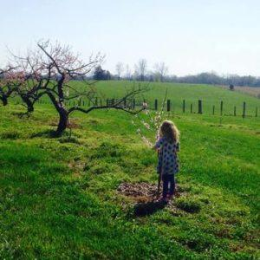

#### [**Overall Farms**](http://overallfarms.com/index.html)**, Bowling Green, KY**

Overall Farms is a family owned and operated business run by Bryan and Lara Bailey. They work in partnership with Lara’s step-dad and mother, Don and Nancy Hayden, and with our long-term family friend, T.E. Bullington. Beef cattle, laying hens, and an orchard are maintained on multiple properties in the area of Bowling Green and Smiths Grove, Kentucky. Their name is indicative of our commitment to farm in a way that benefits the overall good. Overall Farm desires to utilize farming methods that reflect responsible stewardship of the land, plants, and animals and that takes into account not merely short-term benefits but also the long-term impact of our farming methods. Bryan thinks,

*“Furthermore, we care about our customers’ overall well-being. This means taking into account the way that our food affects your long-term physical and financial health.”​​*

#### [**Elmwood Stock Farm**](http://elmwoodstockfarm.com/)**, Scott County, KY**

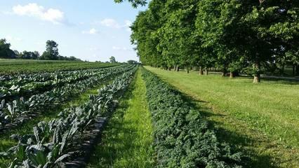

Elmwood Stock Farm is 550-acre, sixth-generation farm that began as a breeder of stock cattle, but has transitioned over the years to include more products, including organic produce. The farm is owned and operated by Cecil and Kay Bell, with help from children, John Bell and Ann Stone. The family has been farming for a long time. As their family transitioned from tobacco to other crops, particularly food crops, they began to question the use of chemicals, dependency on petroleum, use of synthetically designed products, and that made them start looking more at what was put on the food that people eat in this country. That led them to learning and searching for more ways to grow good food that is healthy, that led us into certified organic over a number of years. Because they were an active farm, they didn’t just decide one day to be organic. They had to transition their knowledge, and the fields, and the products and the animals, everything.

#### [**Ballew Farms**](https://www.facebook.com/BallewFarms/)**, Richmond, KY**

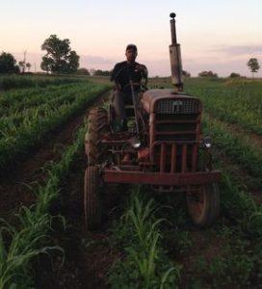

Ballew Farms is a seven-acre plot of land that Lonzo Ballew refers to as the “garden.” He and his brother, Leroy, run the farm, which produces everything from alfalfa grass for horse feed to people food like tomatoes, corn, sweet potatoes and bell peppers. Lonzo has said, “We’re third generation on the farm. We grew up with a family garden. Actually, our family garden was a quarter acre, which not only supplied our family, but close relatives as well. We just continued that and expanded it. Our primary farm income came from tobacco and cattle years back, but as time has evolved and tobacco has been played out, we’ve substituted with alfalfa grass. We supply a lot of Lexington farms with the alfalfa. It’s our main source of income from the farm, but we do continue the garden, supplying family and (creating) a source of income as well.”​

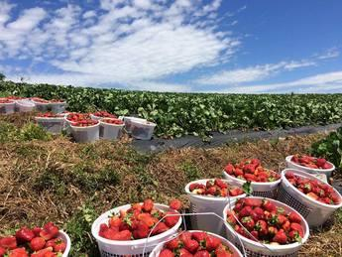

#### [**Van Meter Farms**](http://vanmeterfamilyfarm.com/)**, Clarkson, KY**

As a fifth-generation family farm in Clarkson, Ky., Danny and Trish Van Meter and their 10 children, ages 4-26, provide quality, home-grown produce. Strawberries are their largest crop, having provided them for all six years of New Roots’ Strawberry Jamm Fest, some years up to 500 gallons! They started with 1,100 strawberry plants and it doubled about every year until they reached 3-acres or 36,000 plants. They added several other crops, sweet corn, watermelon, so on and so forth. Danny remarked, “But once we got to that many (plants) the kids said, ‘Dad, that’s enough now; we know how to work.'”